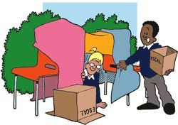  Outdoor Learning  - Use natural objects to make a picture of  an animal you love. Take a photo and bring it  to school.  - Make a den outside where you can shelter from the sun.  - Whilst out and about see if you can find all of the letters of the alphabet on different car number plates.  Year 1 Family Learning Ideas  Our Wonderful World | Things to make and do:  - Make a ‘dish’ from another country. Write some words to describe what it tastes like.  - Make a flag - which country does it come from?  - Make and decorate a paper plane. Write on it where you would like to go and why.    - Make a collage of the best things to do in and around your home town; where is your favourite place and why?
  Places to Visit:  - Go for a walk around your local area identifying the human and physical features.  - Pay a visit to a farm or zoo – which is your favourite animal and why? Take a photo to bring to school.  - Go to a ‘pick your own’ farm. What fruits and vegetables can you find? Where else in the world might they grow?  - Visit a shop that sells pictures, or an art gallery. What colours can you see mixed in the paintings? How would you make them? Make your own version of the painting. | Research Ideas:  - See if you can find out more about the festivals in a country of your choice. What foods do they have? What does the flag look like? What animals live there? What is the weather like?  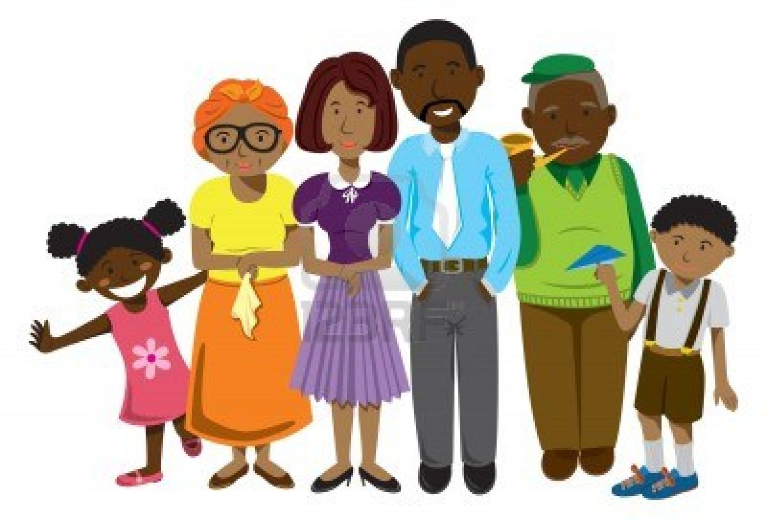  - Find out about where your family originally come from. Have your parents always lived in Yateley? What about your Grandparents?

