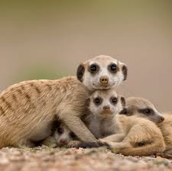
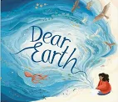
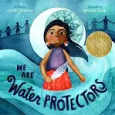
ICT
The online safety units within the Computing Scheme of Work provide in-depth coverage of computing related online safety aspects. It is also beneficial to cover aspects of online safety within whole school and PSHE contexts.

Music – Carnival of the Animals:
The children will listen with increased concentration to sounds/music and respond by talking about them using music vocabulary, or physically with movement and dance.
They will also identify different qualities of sound (timbre) e.g. smooth, scratchy, clicking, ringing, and how they are made.
Music- Composing music inspired by birdsong:
The children will be composing using a non-musical stimulus and creating music inspired by birds and birdsong. They will also be improvising and playing a solo on instruments.

Maths
In Maths we will also focus on the skills of addition and subtraction using a variety of equipment to solve problems, e.g. bead strings; number lines and cubes and recognise and use the symbols ‘+’ ‘=’ ‘-‘.

We will also focus on recapping their understanding of shape from Year 1. Before learning about the properties of shapes, children need to recognise and name both 2-D and 3-D shapes and differentiate between them. It is important that children have the chance to see and feel the shapes. They should begin to understand that 2-D shapes are flat and that the manipulatives they handle in class are representations of the shapes.
.

History- Movers and Shakers
We will be learning about the five statements from Dawson's model that will help them identify people who are historically significant and use the words year, decade and century to describe dates and times. We will learn about the life and impact of a significant person in the locality and of 10 significant individuals from around the world. about the impact of their actions. We will also carry out an independent study of a significant person from the past and learn about people who are significant today.
English
We are looking at the story ‘We are Water Protectors’. The children will explore the true story of the narrative, and produce descriptive non-fiction writing in different forms, such as writing the life-cycle of water, identifying environmental issues, researching Native American tribes and creating a campaign to look after a local water.

We will then be looking at the story ‘Dear Earth’. The children are challenged to think about and discuss the
problems and solutions the planet faces and will write a persuasive speech encouraging the public to look after the environment. Children will use all the skills and vocabulary covered to write their own extended informative leaflet about protecting the environment. Children will finish with a letter to the earth, using Tessa’s letter from the text and celebrating their own dreams and aspirations.

R.E. – Candle light as a symbol.

In RE we will explore how candle light is used as a symbol in both Christianity and Hinduism. We will compare how it is used as a symbol in Diwali and Advent and why it is used as a symbol.

Autumn 2 Term
Year 2 Topic Web

Science: Animal Survival:

This project teaches children about growth in animals by exploring the life cycles of some familiar animals. They build on learning about the survival of humans by identifying the basic needs of animals for survival, including food, water, air and shelter.

P.E.
Indoor P.E. Dance- The children will explore space and how their body can move to express an idea, mood, character or feeling. They will develop their travelling actions and use them in response to a stimulus.
Outdoor P.E. Continuing to work with Coach Toby to develop coordination and an understanding of a range of different sporting activities.

Still Life
We will look at examples of still life.

We will look at examples of still life paintings and then use them as inspiration for our own still life pictures.

