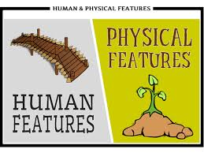  Outdoor Learning  - Go into your back garden and identify all the human and physical features.  - Go to the Local park and identify all the human and physical features. Look at what things are made of.  - Go to the local woods can you find human and physical features. Can you take photos.  Year 1 Family Learning Ideas  United Kingdom | Things to make and do:  - Research and make a traditional dish associated with one of the four countries in the United Kingdom.  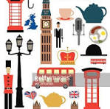  - Make a map of the United Kingdom out of recycled materials.  - Use Lego to build something to represent  the United Kingdom.
  Places to Visit:  - Visit the Capital city of England “London”.  - Visit some of our local towns.  - Take a bus to Camberley.  - Visit Reading think about how similar and different it is to Yateley.  - Visit a restaurant or Cafe. | Research Ideas:  - Research a town in the United Kingdom and identify some of the human and physical features.  - Find out about the four countries in the United Kingdom.  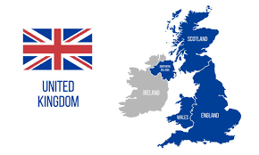  - Research where your family originate from how far is it from where your family live now.

