

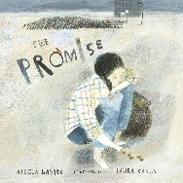
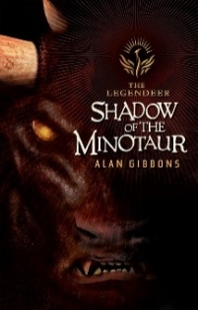
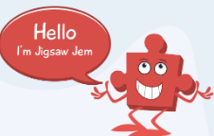
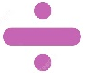
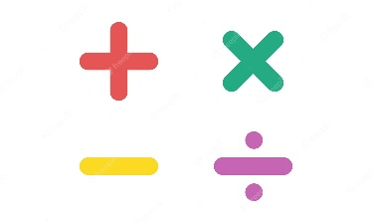
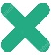
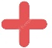
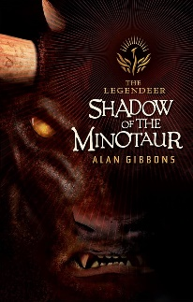=
Music – ‘Twinkle Variations’
During our music lessons, we will be exploring ‘Theme and Variation.’ Theme and variations is a musical form that has been used by composers for centuries. The composer chooses an often simple tune and then creates multiple versions (variations) of it by changing it in subtle ways. Children will be able to decipher a graphic score, play Twinkle, twinkle, little star and create variations using a wide variety of composing techniques.

English – ‘Shadow of the Minotaur’

We will be continuing our English learning of Nicola Davies’ book ‘The Promise’. The children will be investigating the impact of using a range of modal verbs and specific punctuation choices, as well as building their vocabulary to create figurative phrases to write poetry. The outcome will culminate in children writing their own sequel in the form of a narrative poem to continue the story cycle. Throughout our writing, we will be focusing on implementing words from the Year 5/6 statutory spelling list and using a range of varied punctuation to meet the standards for the end of Year 6 writing.

Our second English unit will be based around the first chapter of the ‘Shadow of the Minotaur’ by Alan Gibbons. Our first unit outcome will involve writing a setting description of the labyrinth maze, applying all grammatical and language features that we will study beforehand. Our second outcome will be writing a character description of the Minotaur, using a range of sentence structures to convey emotions and build tension. Our final writing outcome will involve writing a narrative extract from chapter 1 that includes dialogue. We are going to be focusing especially on using high standards of presentation,
accurate spelling and neat handwriting when publishing final
outcomes.

In our Destination Reader sessions, we will be having a
huge focus on answering SATS style comprehension
questions based on a range of different text genres. Weekly,
the children complete a mock style set of SATS questions to
consolidate their understanding and to practice answering
different styles of questions, e.g. multiple choice, find
evidence, tick the correct, etc.

As the children also sit a Grammar, Punctuation and Spelling
SATS paper too, these skills will be continually revisited.
French – Hobbies and sports

Throughout the French unit, we will be exploring sports, hobbies and activities that we enjoy doing in French! By the end of the unit, we will be able to write sentences describing the sports we play, write personal pronouns and also read blogs to understand what some French children enjoy doing.
R.E: Resurrection

In our R.E lessons, we will be looking at the concept of Resurrection, exploring why it is important for Christians, the experiences people have had with this term and also the significance of a cross symbol.
ICT: Text Adventures
In our computing curriculum, we will be following the Purple Mash scheme. The focus for this half term is on text adventures. A text-based adventure is a computer game that uses text instead of graphics. We will be exploring and modifying two kinds of text-based adventure games using two different tools before debugging and improving an existing text adventure.
PSHE: Healthy Me
Following the Jigsaw scheme, we will be exploring how to make healthy choices around diet, exercise and how to maintain healthy friendships. Here are some of the key areas that we will learn about:
- How to take responsibility for my health
- Making positive choices that benefit my health and wellbeing
- Different types of drugs and their effects on the body
- Exploitation and things that are against the law
- Why some people join gangs and the risks involved
- What it means to be emotionally well
P.E.
Indoor P.E.: Gymnastics
In our P.E lessons on a Wednesday, we will be recapping and refining our Gymnastics skills that we started to learn in Autumn 2. In this unit, the children will use their knowledge of compositional principles, e.g. how to use variations in level, direction and pathways when developing sequences. They build trust when working collaboratively in large groups and are given the opportunity to receive and provide feedback.

Outdoor P.E: will be led by the Chelsea football foundation on a Monday. This half term the focus is Basketball.

Science: Electricity

This unit teaches children about electrical circuits, their components and how they function. They recognise how the voltage of cells affects the output of a circuit and record circuits using standard symbols. It also teaches children about programmable devices, sensors and monitoring. They combine their learning to design and make programmable home devices.

Spring 2
Year 6 Topic Web

Maths

The start of this half term will focus on the following domains:
- Shape- angles, properties of 2D/3D shapes, nets
- Position and direction- reading coordinates, translations, reflection
- Statistics- pie charts, line graphs, reading and interpreting data
- Ratio
As we draw ever closer to SATS, we will be revisiting domains that frequently appear in SATS papers which are the four operations, fractions, decimals and percentages.
We are continuing daily Arithmetic practice in school and this is having a huge impact on the children’s Arithmetic scores in the mock SATS papers we have been doing!

