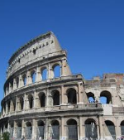
Places to visit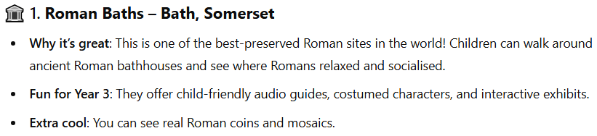
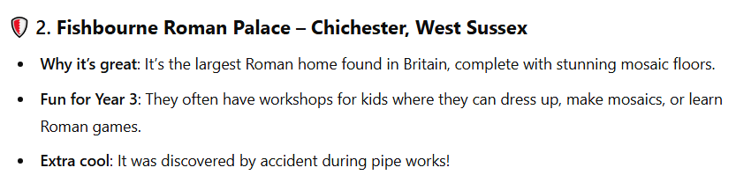

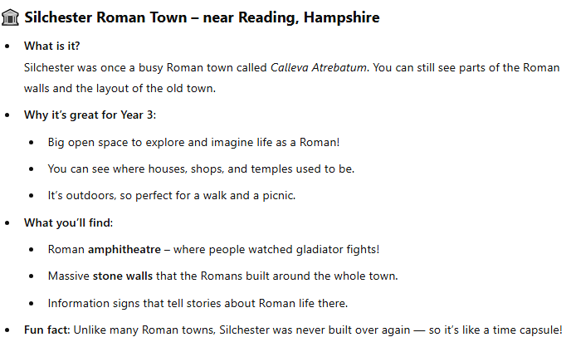

Things to make
- Roman shields
- Roman helmet
- Mosaic art
- Roman bread or honey cakes
- Shadow puppets
- Shadow drawing
- Make a simple pinhole camera

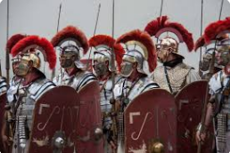
Research ideas
- Research the Roman life – and create a fact file all about them
- Research and find out about the Roman army
- Explore the legacy that the Romans left for the UK
- Find out about different Roman myths and gods and goddesses

Remarkable Romans
Home Learning Summer 1.

Other activities
- Make a shadow puppet and retell a Roman myth
- Create a map of the top Roman sites in the UK
- Visit https://www.english-heritage.org.uk/visit/places/hadrians-wall/
- Listen to audiobooks on SORA

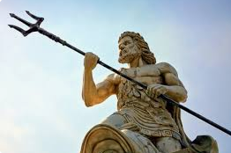
Times tables
- Practise your times tables – 2, 5, 10, 3, 4, and 6s using TT Rockstars

