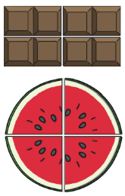
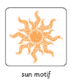
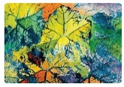
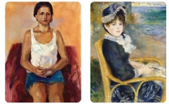
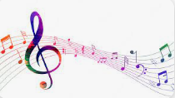
PSHE:
We will focus on ‘Relationships’. The children will explain why they have special relationships with some people and how these relationships help them feel safe and good about themselves.
They will also explain how their qualities help these relationships.

History:
In History we will be carrying out the School Days project. The children will have the opportunity to take part in a traditional Victorian class (Date to follow) and will learn about the differences between schooling in the Victorian era and schooling today.
Maths

In Maths we will be working on numbers to 100 – recognising them, ordering them and partitioning them into tens and ones. We will be continuing our work on number lines to fill in missing numbers and estimate where numbers to 100 belong along a number line.

We will also be continuing to use number bonds and other number facts to help us do basic calculations quickly. We are going to start learning to count in 2s, 5s and 10s.

We are also going to be about position and direction (turns) and fractions – e.g. halves and quarters.

English:

One of the big foci we have in Year 1, is our Phonics sessions. We will be having phonics every day where we will be learning a new sound and during these sessions we will also read in our small phonics groups.

In English we will be enhancing our writing curriculum using a program called Literacy Tree. We will start the term by reading Lost and Found then we will use the book Lubna and the Pebble. We will be writing our own narrative about giving something.

Please keep reading every day with your children and encourage them to watch their phonics videos. It Is essential your children become fluent readers by the end of year one. We will have our phonics screening test this term.

Art

In Art this term, we will be learning about
faces and portraits. We will be using
drawing, collage and painting techniques
to create our own ‘funny faces’.

We will also be looking at rain and sunrays and creating our own rain and sun pictures using collage, collagraphy and printing techniques.

P.E.

Indoor P.E. for this half-term is Yoga. We will be connecting to our bodies, breath and mind.

Outdoor P.E. continues to be led by the Chelsea football foundation on a Tuesday. This half term the focus is on basketball and rounders.

Music

In Music we will be learning to repeat and sing back tunes. We will experiment with pitch, tone and rhythm. We will also have the opportunity to play different instruments to develop our musical skills.

Computing:

In Computing, the children will be using the Purple Mash programme to support them with their learning. We will be developing our independence with logging on and creating simple codes using 2code on purple mash.
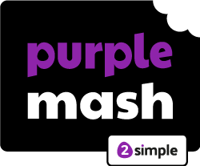
Forest School
In Forest School we will continue experiencing our outdoor learning with Mrs Martin.
R.E.
Our RE this half-term focuses on Special Places
Summer 1
Year 1 Topic Web
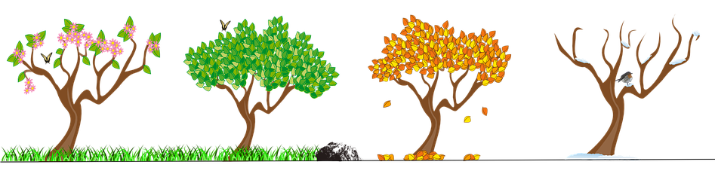
Plants and Seasons

Science: Weather and Seasons and Plants

During this topic, continue looking at different seasons and weathers. We will be looking at how plants change during different seasons. We will also have a look at animals and how they change and respond to different seasons. We will be looking at deciduous and evergreen trees and comparing them as well as learning about what happens to the weather as the seasons change.

